

Skincare Recommendation System
Recommendation of Products Based on Similarity and Sentiment of Reviews

April 2, 2021

Taniya Adhikari
Preliminary Analysis

Table of Contents
1 Abstract 2
2 Intro/Background 2
3 Methods 3
4 Results 4
5 Discussions/Conclusion 6
6 Acknowledgements 6
7 References 6

ABSTRACT
This project focuses on building a knowledge-based recommendation system for skincare products based on user preferences or user inputs. The motivation of this project is to make consumer shopping experience quick and easy by successfully recommending top products from the wide variety of products available in the market. For this type of recommendation system, I will be using product reviews from an e-commerce website for each product and perform sentiment analysis to find the top products and then matching it with user preference data. For this project, I narrowed down products to only k-beauty brands (Korean skincare) because they are new to global market and has been quite successful in recent years and will be using data from the Soko Glam because it is the largest seller of k-beauty products.

INTRO/BACKGROUND
Business Understanding
For the longest time beauty and personal care industry has been ruled by the legacy brands or the brands that are easily available on the store. However, in recent years industry had shifted towards ecommerce, due to this there has been a rapid growth in the industry which led to increase in newer brands with more options in skincare products. We are introduced with different types of skincare products from all over the world and countries like Korea, Japan, and India. There are ten thousand plus beauty products out there and new products add on daily basis which makes it hard for consumers to choose from. The purpose of this project is to build a tool to find top skincare products for specific skin concerns and suggest products to the user based on user query.
Business Problem
The problem with a vast variety of skincare products is that consumers are burdened with a challenge of choosing from numerous products, which is often time consuming and difficult to select the right product for their skin concerns. Usually, consumer will look up reviews for products to find the best match, however, overflowing reviews online becomes overwhelming and consumer must read through reviews to find products. In this project, I attempt to find a solution by developing a knowledge-based recommendation system that takes user preferences and match it with the top products based on sentiment of reviews.
Target Variable
Because it is unstructured analysis, there is no specific target variable. Although, I will be performing similarity and sentiment analysis, thus I will be calculating scores for those two. So, for reviews online, I will be calculating polarity (positive or negative) sentiment score and for similarity between the user preference and reviews, I will be calculating similarity score.

METHODS
Data Understanding and Preparation

The data required for this project is information on k-beauty skincare. Some of the variables for this project is product name, product brand, product type, product description, price, product id, product reviews. There was no available dataset for this project, thus for data collection step, I scraped product list and information from Sokoglam.com and reviews using requests and BeautifulSoup library. The first step I did was get product information, product id and product name and converted that into dataset, then using product id, I retrieved reviews for each product. Furthermore, I removed any item that does not fall into skincare products and removed reviews that was a reply from a seller to the customer. For text analysis, I turned reviews into all lowercase and removed all punctuations. A common challenge with large text data is that corpus contains large vocabulary. To reduce number of words, I removed stopwords using custom list and performed lemmatization.

Modelling
For knowledge-based recommendation system, I had to use a different approach. Since it is slightly different from collaborative and content-based recommendation. I did not have user history to recommend product, instead I was using user input to recommend top products. The first step for this type of analysis was to get product features from the product reviews. For this step I used Bag of Words model to turn reviews into matrix of features. Second, for user preferences, I created a list of features for user to choose from which included features such as skin type, skin concerns, price, product type. Third, I calculated matching scores between user inputs and the reviews using cosine similarity. After calculating similarity score for each review and user inputs, I created a separate word2vec model for k-means clustering to predict positive or negative sentiment for each review. To recommend product, I further calculated the weighted sum of average similarity score and average sentiment score for each product.

RESULTS
To see my model performance, I created a list of fake user input to check the accuracy of the results. The user input was:
Skin-Type: Oily
Product-Type: None
Skin-Concern: acne, clog pore
Skin-Solution: skin glow, smooth skin, hydration
The results of this preliminary analysis were mixed because I have not finished the data pre-processing yet. Two of the three products matched with user preference (I manually checked this through Sokoglam website). Third one, had slight lower similarity.

Figure 1. Top results
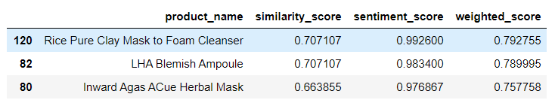
Figure 2. Sentiment Score
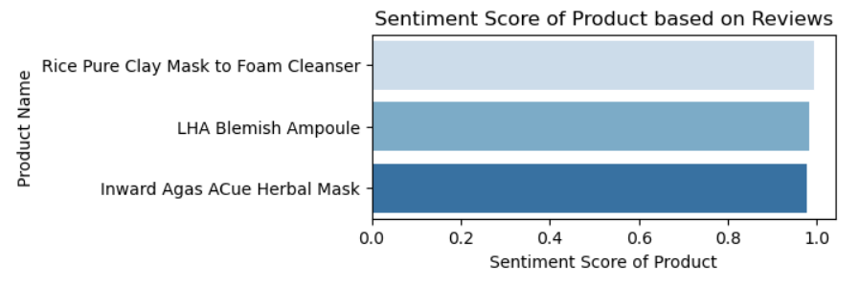
Figure 3. Similarity Score
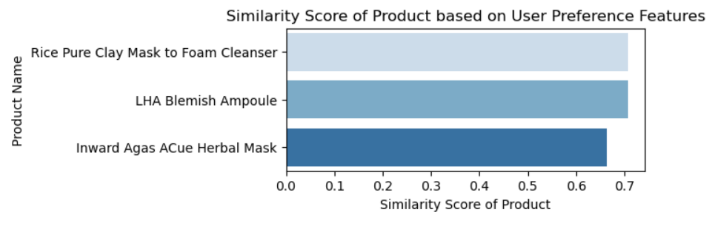
Figure 4. Weighted Score
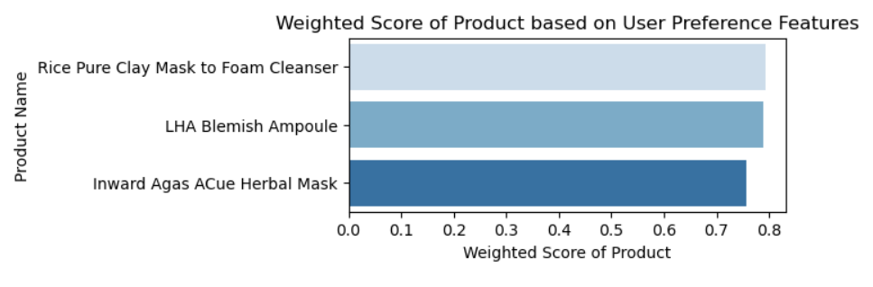

DISCUSSION/CONCLUSION
There is still some work to do for this project. To reduce vocabulary and to get correct similarity scores, I must carefully look for words that are similar or are synonyms. This can be done many ways; one way is to do fuzzy matching. For sentiment analysis, I must set some evaluation metrics to evaluate clustering model. Further, I need to add pricing and product type into algorithm, so model can recommend correct products.

ACKNOWLEDGEMENTS
I would like to thank my husband Bibek Adhikari and my friend Mayur Nag for helping me with data scraping and providing insights in this subject. If it not for them, I would have not been able to create a dataset for this project, due to difficulties in the website without pagination.

REFERENCES
- Soko Glam - Korean Skin Care, Beauty & Makeup Products. (n.d.). Retrieved March 28, 2021, from https://www.sokoglam.com/.
- Roberts, R. (2021, March 08). 2021 beauty industry trends & Cosmetics Marketing: Statistics and strategies for your ecommerce growth. Retrieved March 28, 2021, from https://commonthreadco.com/blogs/coachs-corner/beauty-industry-cosmetics-marketing-ecommerce#:~:text=How%20big%20is%20the%20beauty,exceed%20%24716B%20by%202025.
- Sabanoglu, T. (2021, February 16). Cosmetic industry growth. Retrieved March 28, 2021, from https://www.statista.com/statistics/297070/growth-rate-of-the-global-cosmetics-market/

